## **Task 1**

**Test Case ID**

* **UI-PT.1**

**Scenario**

* **Purchase a Pet and Check Order**

**Preconditions**

* Browser is open at <https://petstore.octoperf.com/>
* New user to website

**Test Steps**

1. Click “Enter the Store” and landed on Store page
2. Select Fish option on the furthest left-hand side
3. Click Fl-FW-02 link for Goldfish
4. Click EST-20 link for Adult Male Goldfish
5. View 5937 Goldfish in stock, click “Add to Cart” button
6. Taken to Shopping Cart page
7. Click “Proceed to Checkout” button
8. Taken to landing page to prompt to sign-in
9. Click “Register Now!”
10. Taken to New Account Form page
11. Fill out details new account (see A1 Appendix) and click “Save Account Information” button
12. Taken back to Store page, click “Sign In” button
13. Credentials pre-filled, click “Login” button and received “invalid username or password. Signon failed.”
14. Try again with new credentials and click “Login” button which was successful showing Account Details.
15. Click “JPetStore” home button and landed on Store page
16. Followed same steps from 2-6 above.
17. Review cart and change Quantity from 3 to 1, press “Enter” on **keyboard** to confirm
18. Click “Proceed to Checkout” button
19. Land on Payment and Billing Address Form page (See A2 Appendix) with details prefilled. Mark checkbox for “Ship to different address...”
20. Taken to Shipping Address page, which I completed with new address (see A3 Appendix) and click “Continue” button
21. Taken to Order Confirmation page (see A4 Appendix) and click “Continue” button
22. Take to Order Submitted page (see A5 Appendix)
23. Click on “My Account”
24. Taken to Account Information Page, Click on “My Orders”
25. Confirm Order Number is present (see A6 Appendix), click into order number 135771 and confirm details.
26. Click “Sign Out” to land back on Store Page

**Expected Result**

* Pet is added to the cart successfully
* Cart page shows the correct pet name and able to change to quantity 1 with correct pricing
* Payment is accepted and Order details are correct
* Order ID consistent in Order confirmation, Order submitted and My Orders when signed into account

**Actual Result**

* Pet is added to the cart successfully and shows correct pet and cost
* Account Prompt and Account Set Up successful
* Cart quantity changed to 1 successful with correct prices
* Payment details, billing and shipping details are correct and able to be changed
* Order submitted successfully and order details are correct in the order submission and order id in My Orders except time:
  + Order time is an hour off Sydney time and date is not in standard DD/MM/YYYY but D/MM/YYYY see A4
  + Time is inconsistent with daily time in My Orders is set to 12:00 see A6 Appendix

**Summary**

Pass for positive test case scenario of new user buying single pet and checking order ID. However, just some minor details with time format being not Australian standard day/month/year and ordering times are inconsistent with Order Confirmation and time listed in My Orders.

**Appendix**

A1. Account Details

### **User Information**

|  |  |
| --- | --- |
| User ID: | John Smith |
| New password: | fake123 |
| Repeat password: | fake123 |

### **Account Information**

|  |  |
| --- | --- |
| First name: | John |
| Last name: | Smith |
| Email: | [Jsmith@gmail.com](mailto:Jsmith@gmail.com) |
| Phone: | 0430558808 |
| Address 1: | Level 8/207 Kent St |
| Address 2: |  |
| City: | Sydney |
| State: | NSW |
| Zip: | 2000 |
| Country: | Australia |

### **Profile Information**

|  |  |
| --- | --- |
| Language Preference: | English |
| Favourite Category: | FISH |
| Enable MyList | [x] |
| Enable MyBanner | [ ] |

A2. Payment and Billing Address

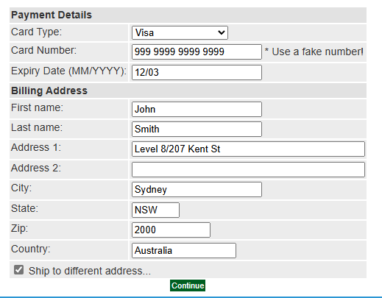

A3. Shipping Address

|  |  |
| --- | --- |
| **Shipping Address** | |
| First name: | John |
| Last name: | Smith |
| Address 1: | 99 Rawson Street |
| Address 2: |  |
| City: | Auburn |
| State: | NSW |
| Zip: | 2144 |
| Country: | Australia |

A4. Order Confirmation page

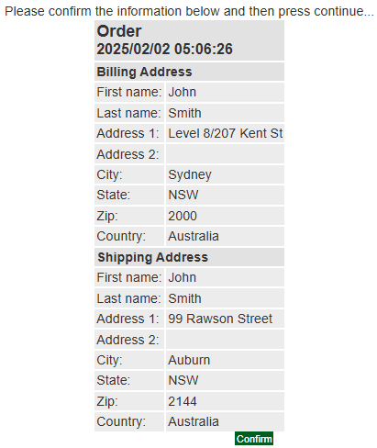

A5. Order Submitted page

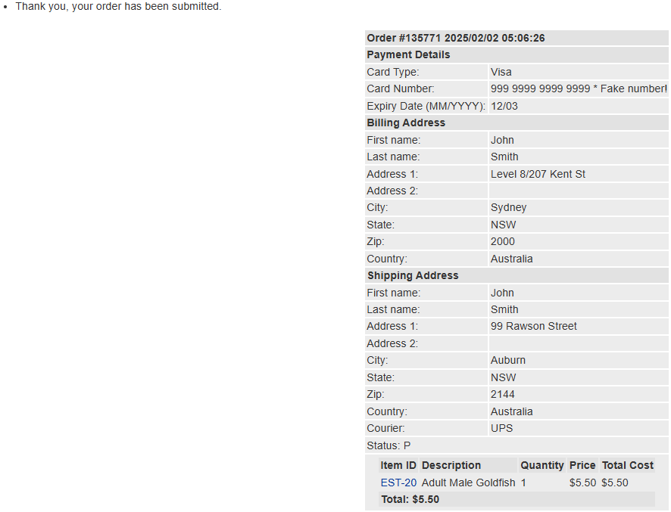

A6.

